Assignment #3

***Prepare a WBS (you may do this without Microsoft Project) with the steps that must be completed before Vern Toney can contact outside vendors. If Vern starts August 1st, 2016, how long will it take to get ready to contact outsourcing vendors?***

It would take Vern approximately 24 days or about 3 and a half weeks to complete this IT group review project. (just an FYI I would have created a Gantt chart or something similar to show this but in the WBS example the chart was similar to the one I created below. If this is not correct I can certainly create a different chart.)

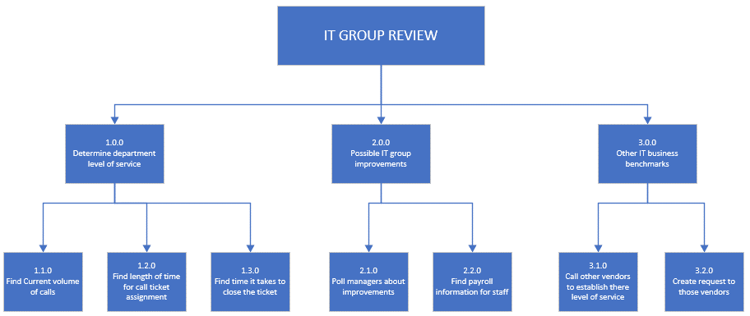

Case: Friendly Assisted Living Facility-3 (pg 104)

***Q1: Define the deliverables for this project***

* Construction of the facility
* Building design
* Define food service needs
* Define housekeeping needs
* Define staffing needs
* Define policy needs
* Procedure development
* Create budgets for each project area
* Create payroll and accounting systems for facility
* Define and setup telecommunications and information systems for facility
* Create preliminary marketing plan and communication package for community and hospital staff
* Organizing a ground-breaking event
* Design assessment tools for determining residents’ level of medical needs when moved into facility
* Develop management structure for the facility
* Identify all government regulations and industry standards that pertain to assisted living facility and practices.

***Q2: Define the constraints and assumptions for this project***

The first major constraint is man power and how long it will take to achieve all those deliverables listed above. The next would be the ability or level that those deliverables can be achieved, since some might not work in the current circumstances until other objectives are more defined.

***Q3: Develop a preliminary Level 1 WBS***

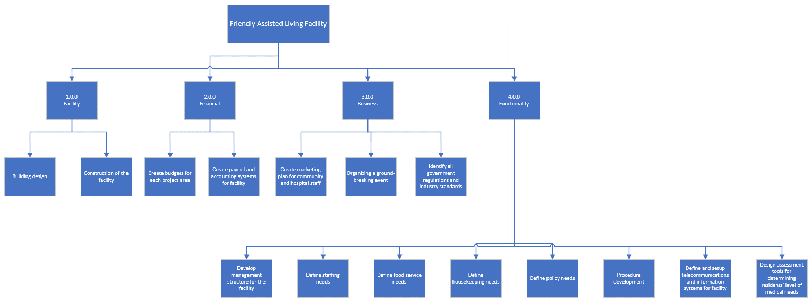

***Q4: Develop a RACI matrix for this project based on the level 1 WBS.***

See attached Excel document

***Q5: Would a Project Charter have been useful here? Explain.***

I do think a project charter like the explanation given would be important and useful in this scenario. It would not only be a great document to refer too but could also help new employees and members if they join after the initial parts of the project.